1. . Discuss briefly about JSP processing.

JSP (JavaServer Pages) processing involves converting JSP code into a servlet, which is then executed to generate dynamic web content. Here’s a brief overview of the JSP processing steps:

1. **Translation**: The JSP file is translated into a servlet. This step converts the JSP syntax and directives into corresponding Java code in the form of a servlet.
2. **Compilation**: The generated servlet code is compiled into a Java bytecode (.class file).
3. **Class Loading**: The compiled servlet class is loaded into the web server's memory.
4. **Instantiation**: An instance of the servlet is created.
5. **Initialization**: The servlet's init method is called to perform any required initialization tasks.
6. **Request Handling**: For each client request, the servlet’s service method is called. This method determines the HTTP method (GET, POST, etc.) and calls the appropriate method (doGet, doPost, etc.).
7. **Response Generation**: The servlet generates the dynamic content (usually HTML) and sends it back to the client.
8. **Destruction**: When the servlet is no longer needed, the server calls the servlet’s destroy method to release resources.

Describe how to connect to database using JSP with suitable example?

**9 . Steps to Connect to a Database Using JSP**

1. **Load the JDBC Driver**: Load the database driver class.
2. **Establish a Connection**: Use the DriverManager to establish a connection to the database.
3. **Create a Statement**: Create a Statement or PreparedStatement object to execute SQL queries.
4. **Execute a Query**: Execute the SQL query and obtain the result set.
5. **Process the Result**: Iterate through the result set and process the data.
6. **Close the Connection**: Close the database connection and other resources.

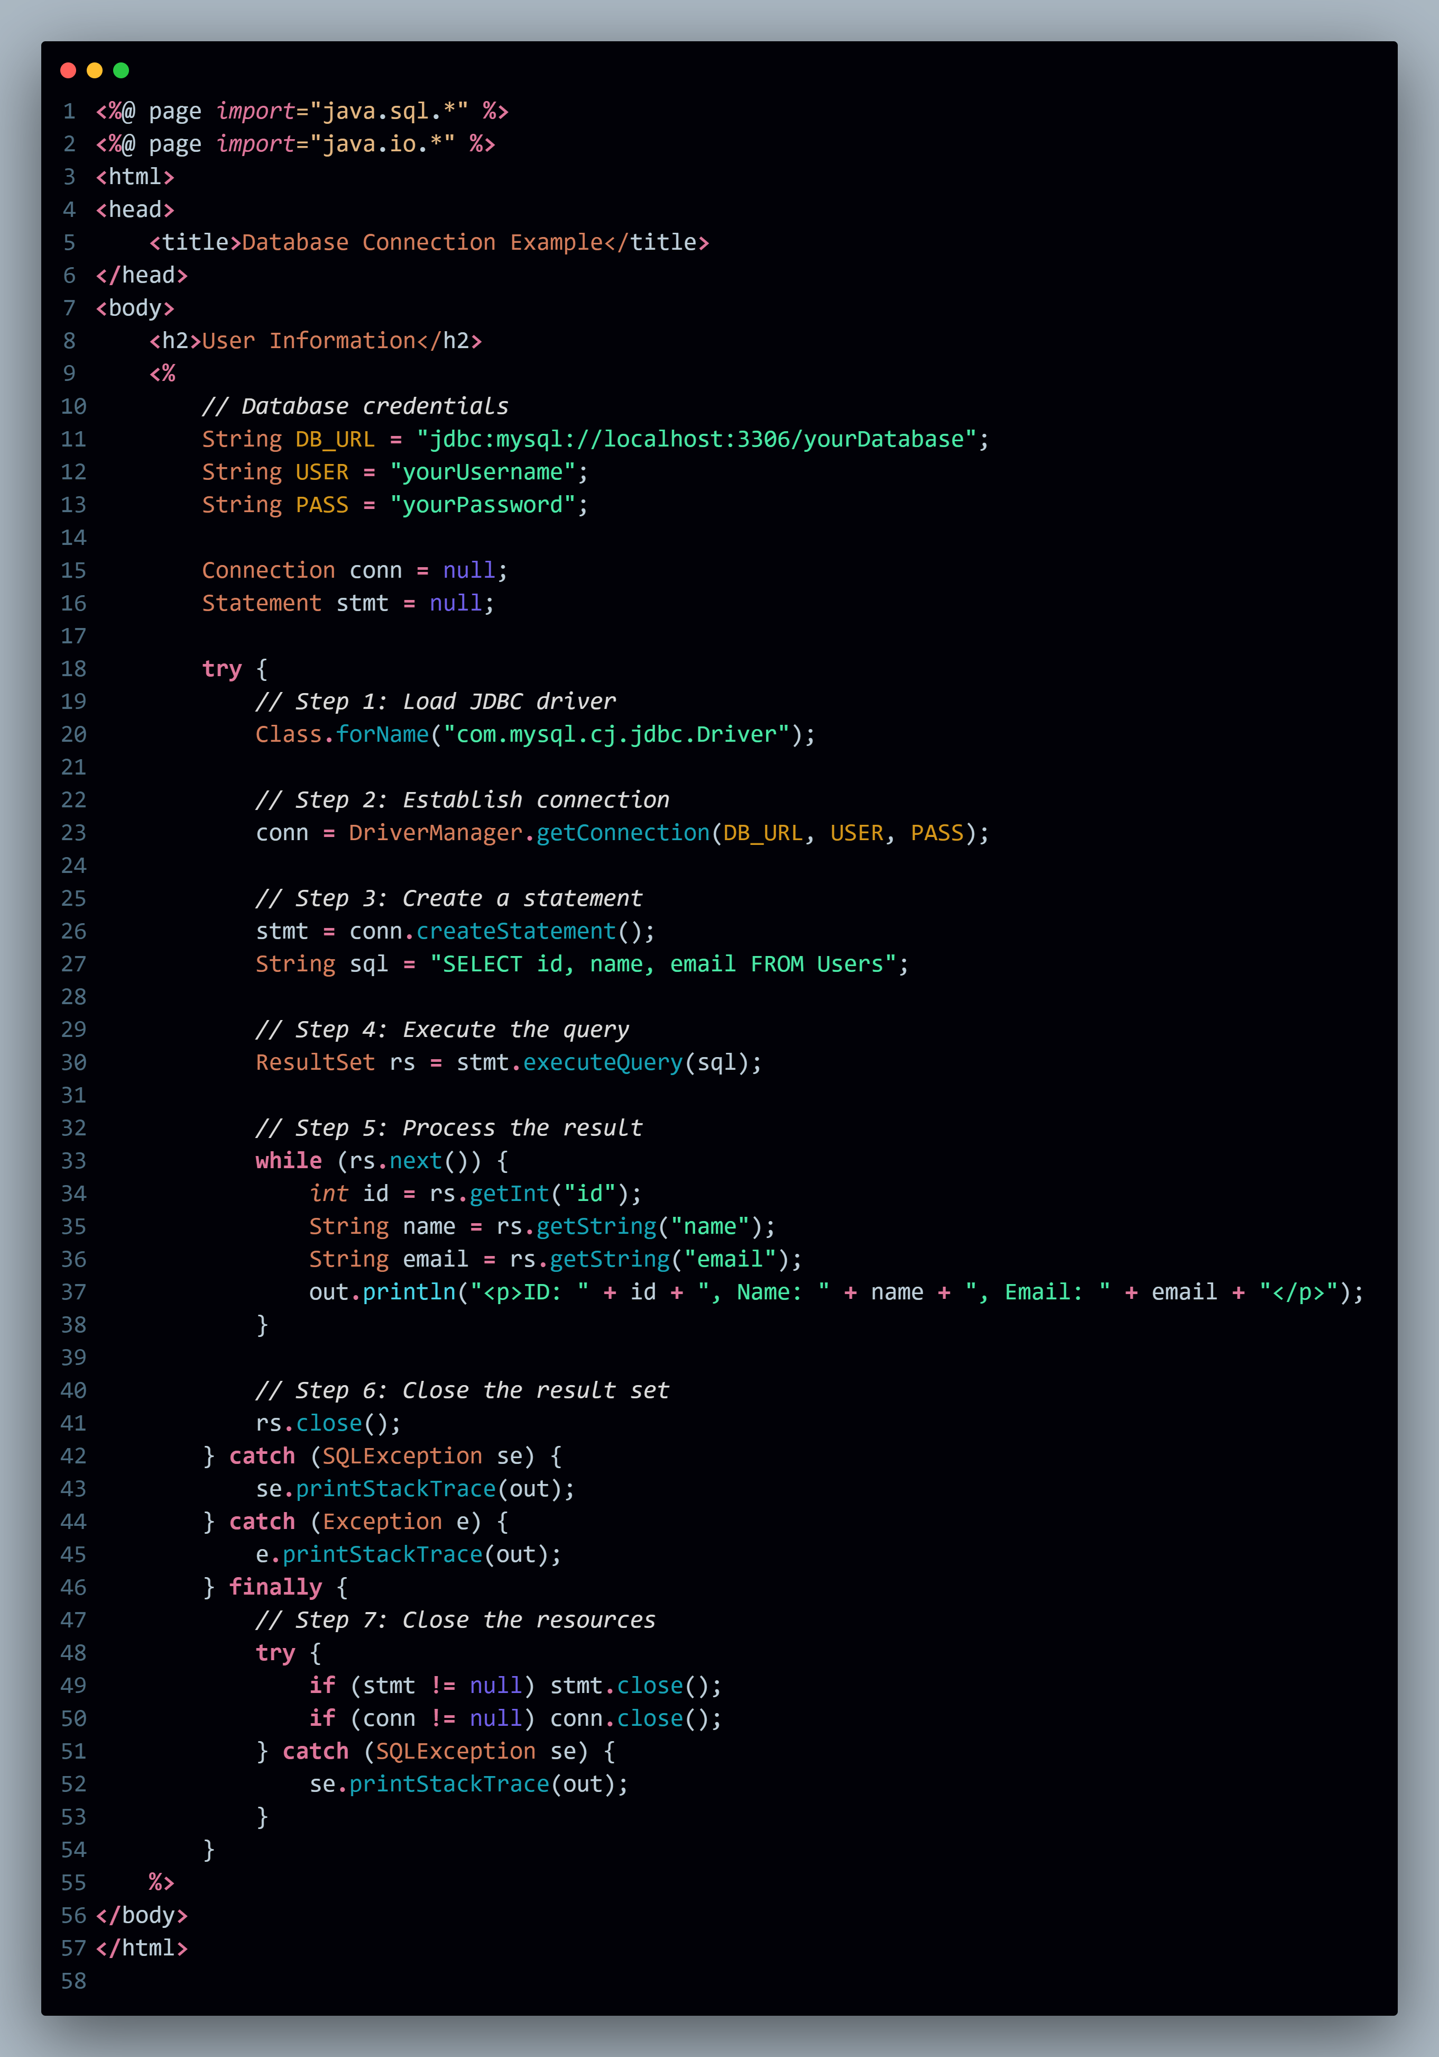

* 1. .Discuss about Scripting elements in JSP ?

Scripting elements in JSP (JavaServer Pages) are used to embed Java code directly into the HTML markup of a JSP page. There are three main types of scripting elements in JSP:

1. **Scriptlets**
2. **Expressions**
3. **Declarations**

**1. Scriptlets**

Scriptlets allow you to embed Java code within the JSP page. The Java code written in scriptlets is inserted into the service method of the generated servlet. Scriptlets are enclosed within <% %> tags.

<%

// Java code

String message = "Hello, World!";

out.println(message);

%>

### 2. Expressions

Expressions in JSP are used to output the result of a Java expression directly to the client. They are evaluated at runtime and automatically converted to a string. Expressions are enclosed within <%= %> tags.

<%

int a = 5;

int b = 10;

%>

<p>The sum of a and b is: <%= a + b %></p>

### 3. Declarations

Declarations in JSP are used to declare variables and methods that can be used throughout the JSP page. The declarations are placed at the class level in the generated servlet. Declarations are enclosed within <%! %> tags.

<%!

private int square(int num) {

return num * num;

}

%>

<p>The square of 4 is: <%= square(4) %></p>

11.Explain about Session tracking techniques in JSP?

Session tracking is a mechanism used in web applications to maintain state and data across multiple requests from the same user. JSP (JavaServer Pages) provides several techniques for session tracking:

1. **Cookies**
2. **URL Rewriting**
3. **Hidden Form Fields**
4. **HttpSession**

• **Cookies**:

* Store data on the client side.
* Sent with each request to the server.
* Persistent (can be set to expire) or session-based.

• **URL Rewriting**:

* Append session information to URLs.
* Useful when cookies are disabled.

• **Hidden Form Fields**:

* Store session data in hidden form fields.
* Sent with form submissions.

• **HttpSession**:

* Store data on the server side.
* Data is maintained across multiple requests from the same client.
* Simplest and most commonly used method for session tracking in JSP